**CHAPTER – 1**

**INTRODUCTION**

# 1.1Overview

Autism spectrum disease affects the nervous system and impacts the overall cognitive, emotional, social, and bodily health. The common signs and symptoms encompass issues with verbal exchange, trouble with social interactions, obsessive hobbies, and repetitive behaviors. Early recognition, in addition to behavioral, educational, and family therapies - may lessen signs and symptoms and help in development and learning. The primary goal of this system is to capture an image in real-time and recognize whether it is a human face by using the Computer Vision technique. After detecting the human faces from live input, and examining the facial expressions using a Deep Neural Network and If the Predicted facial Emotion is happy, then we will play some Interesting Audio to them using AT mega Microcontroller, which will keep them relaxed and will help them to learn.

# 1.2 Problem Definition

We will be using a Convolution Neural network Algorithm to detect the Facial Emotion and by using the Trained Model we will be identifying the Emotion by comparing the Image of the Live Input with the Model file and then based on the Emotion we will Train the model by playing Rhymes when their Emotion is Happy and we are also using Hardware part as Mental Health is very important to everyone we will be using Galvanic Skin Response Sensor where Electrodes is Connected to the Subject and Based on the Threshold Values we will storing the Data in the Cloud Platform which becomes very useful for the Parents or Caretaker to analyze their Mental Space as well. The reason for focusing on both these aspects are they might have possible anxiety with mingled with the crowd, and By Analyzing the Facial Emotion we can also help them learn things, we believe technology should reach all medium of users and will help them overcome their problems.

**CHAPTER – 2**

**LITERATURE SURVEY**

1. **An Immersive Computer-Mediated Caregiver child Interaction System for Young Children with Autism Spectrum Disorder [11]**

Guangtao Nie and Akshith Ullal , Zhi Zhen Amy R. Swanson, Nilanjan Sarkar(2021)

**DESCRIPTION:**

An immersive Computer-mediated Caregiver-Child Interaction (C3I) system to assist kids with ASD applies IJA skills. C3I could be a novel computerized intervention system that integrates a caregiver within the teaching loop, thereby protecting the benefits of each human and computer-administered intervention. A practicability study with vi dyads (caregiver-child with ASD) was conducted. A close to important increase with medium impact size on IJA performance was ascertained. Meanwhile, physiology-based stress analysis showed that C3I didn't increase the strain on the caregivers throughout the study. To the most effective of our information, this is often the primary autonomous system designed for teaching IJA skills to kids with ASD incorporating caregivers within the loop to reinforce the potential for generalization within the real world.

**MERITS:**

* C3I showed promising results and feasibility.

**DEMERITS:**

* Caregivers need to operate the tablet in C3I, which occasionally distracted children’s attention.

**2. Screening Tool for Autistic Children [14]**

V. Y Tittagalla, R. R. P Wickramarachchi, G.W.C.N.Chandrarathne, N.M.D.M.B.Nanayakkara, P. Samarasinghe, P. Rathnayake and M.G.N.M. Pemadasa. (2019)

# DESCRIPTION:

A person with syndrome Spectrum Disorder (ASD) typically has problem with social and communication skills. within the past few years, there hasn’t been a correct means of distinctive unfit youngsters in land. during this analysis paper, we are going to discuss a way to establish Associate in Nursing unfit kid by considering a mobile applications on with the subsequent factors. establish the attention contact, responsiveness to stimulant, analysis of vocal behavioural patterns, and form. The on top of four factors are going to be the most key areas within the screening method. This tool is formed particularly for distinctive youngsters with syndrome in rural areas in land. the key 3 areas of eye contact, vocal behavior, and responsiveness area unit the screening method is developed for proof of conception during this analysis.

# MERITS:

* In this screening application will help parents/guardians and doctors in identify autism in young children easily, which will save a lot of time and money for them.

# DEMERITS:

* The application only supports android devices.

**3. Intelligent Gaze-Based Screening System for Autism [13]**

Alanoud Bin Dris, Abdulmalik Alsalman, Areej Al-Wabil,Mohammed Aldosari (2019)

# DESCRIPTION:

Accordingly, in our analysis, we have a tendency to square measure getting to speed up diagnoses by combining gaze-based screening with intelligent strategies like machine learning which might act as a transformative step for distinguishing ASD at its early stages. during this analysis, we have a tendency to used Support Vector Machine (SVM) algorithmic program to look at the performance in terms of 4 completely different measures that square measure accuracy, sensitivity, specificity and space underneath the curve (AUC). Results discovered that SVM accomplished high classification performance once applied on our collected eye movement information set.

**MERITS:**

* Used Support Vector Machine (SVM) algorithm to examine the performance in terms of four different measures which are accuracy, sensitivity, specificity and Area under the curve (AUC).

**DEMERITS:**

* This system requires larger datasets to validate machine learning algorithm performance.
* Delayed diagnosis and further intervention.

**4. Computer Vision Analysis for Quantification of Autism Risk Behaviors [12]**

Geraldine Dawson, Kimberly L. H. Carpenter, Kathleen Campbell, Qiang Qiu, Steven Espinosa, Samuel Marsan, Jeffrey P. Baker, Helen L. Egger (2018)

# DESCRIPTION:

# Research on syndrome spectrum disorder (ASD) suggests that behavioural risk markers is discovered at twelve months more matured or earlier, with diagnosing potential at eighteen months. To date, these studies and evaluations involving empiric analysis tend to bank heavily on clinical practitioners and specialists United Nations agency have undergone intensive coaching to be ready to dependably administer rigorously designed behavioral-eliciting tasks, code the ensuing behaviors, and interpret such behaviors These ways area unit thus extraordinarily high-ticket, time-intensive, and aren't simply ascendable for giant population or longitudinal empiric analysis. we have a tendency to developed a self-contained, closed-loop, mobile application with moving-picture show stimuli designed to interact the child’s attention and elicit specific behavioural and social responses, that area unit recorded with a mobile device camera so analyzed via laptop vision algorithms. The results recommend these objective and automatic ways is thought of to help behavioural analysis, and may be fitted to objective automatic analysis for future studies.

**MERITS:**

* These low-cost, objective, and automatic methods can be considered to aid behavioral analysis and can be suited for objective automatic analysis of large and longitudinal studies.

**DEMERITS :**

* It can be easily detected by using sensing technology such as hand flapping, body rocking and, motion trackers.

1. **Simple Touch Sensor-based Game as Ambient Assistive Device for Mild Autism Spectrum Disorder Children [22]**

Sarah Afiqh Mohd Zabidi, Hazlina Md Yusof, Sukreen Hana Herman, Shahrul Naim

Sidek(2021)

**DESCRIPTION**

This paper focuses on the event of an easy bit device primarily based game to unproved psychological feature talent in ASD kids psychological feature skills embrace thinking, learning and resolution issues. the sport designed during this system can facilitate the kid to be told colours and shapes through sorting and classifyıng the blocks. though naming colours and classifying shapes is wont to most adults, it's truly a cognitively complicated task for young kids. the aim of this study is to create Associate in Nursing helpful device which will be a good learning medium for ASD kid and may be utilized by therapists throughout the session. This device will log knowledge in period of time which might facilitate reduce the therapist's work and facilitate them specialise in the kid throughout medical aid.

**MERITS:**

* Therapists Providing an alternative to conventional therapy and data-taking.

**DEMERITS:**

* No experimental test with ASDC.
* Data is stored in an offline computer/laptop .

1. **Design of an Intelligent Agent to Measure Collaboration and Verbal Communication Skills of Children with Autism Spectrum Disorder in Collaborative Puzzle Games [15]**

Lian Zhang, Ashwaq Z. Amat, Huan Zhao, Amy Swanson, Amy Weitlauf (2020)

**DESCRIPTION**

Autism Spectrum Disorder (ASD) could be a neurodevelopmental disorder characterised by core deficits in social interaction and communication. cooperative puzzle games ar interactive activities that may be contend to foster the collaboration and verbal-communication skills of kids with ASD. during this paper, we've designed AN intelligent agent that may play cooperative puzzle games with youngsters and verbally communicate with them as if it's another human player. moreover, this intelligent agent is additionally able to mechanically live youngsters’s task-performance and verbal-communication behaviors throughout gameplay 2 preliminary studies were conducted with children with ASD to guage the practicability and performance of the intelligent agent. Results of Study I incontestable the intelligent agent’s ability to play games and communicate with youngsters inside the game-playing domain. Results of Study II indicated its potential to live the communication and collaboration skills of human users.

**MERITS:**

* The system managed to achieve high accuracy in measuring the verbal-communication skills and collaboration skills using the system-generated features

**DEMERITS:**

* Unlike an actual human partner, ICON2 has the potential to crash or fail. This could cause user frustration. The system did crash and caused for one session during experimentation.

**7. A Review of Early Detection of Autism Based on Eye-Tracking and Sensing Technology [16]**

Zeyad Abdulhameed, Taha Ahmed , Dr. Mukti E. Jadhav (2020)

**DESCRIPTION:**

The current paper could be a review of eye-tracking and sensing technologies that observe and monitor syndrome Spectrum Disorder (ASD). Nowadays, the most important challenge is that the detection of syndrome before the age of thirty six months. The identification of syndrome within the early stage of life will facilitate unfit youngsters improve their social communication and quality of life. Therefore, the technology will support psychologists to urge the correct diagnoses of syndrome and consequently the unfit youngsters will get acceptable treatment for his or her condition. during this review, the main focus is on eye - chase and sensing technologies. The unfit youngsters have totally different basic cognitive process biases in social interactions that may be measured by eye-tracking technology. Moreover, unfit youngsters have some signs that may be simply detected by victimisation sensing technology like hand flap, body rocking and, motion trackers.

**MERITS:**

* Itcan be easily detected by using sensing technology such as hand flapping, body rocking and, motion trackers.

**DEMERITS:**

* They found that autistic children are less interested in the faces and eyes while the typically developing as well as the ASD focus on the mouth, the body and background.

**8. Autism Spectrum Disorder Detection in Toddlers for Early Diagnosis Using Machine Learning [17]**

Shirajul Islam, Tahmina Akter, Sarah Zakir, Shareea Sabreen, Muhammad Hossain (2020)

**DESCRIPTION :**

Our study aims to estimate ASD (autism spectrum disorder) at a sooner doable time and increase accuracy than the previous analysis and cut back medical prices. In our thesis paper, we would like to predict and distinguish between unfit and non-autistic youngsters by employing a machine learning approach. Firstly, we've gathered knowledge from the police investigation aspect the maximum amount as doable. we have a tendency to additionally set some specific queries and check out to search out most correct answers to all or any queries. moreover, supervised learning algorithms ar applied to diagnose whether or not youngsters meet the symptoms of ASD. Among all applied algorithms KNN and Random Forest shows most accuracy and speed to identification. Above all, our final goal is to make a web tool that may offer machine learning-based Associate in Nursing analysis to a user to find syndrome at an early age exactly.

**MERITS:**

* Using the dataset from Q-CHAT and AQ tools, our proposed model can predict using SVM, Random Forest, Naive Bayes and KNN with 83%, 93% ,89% and 98% accuracy in case of toddlers. More Accurate Results.

**DEMERITS**

* Lack of enough large data to train the model and lack of dataset.

**9. Towards Developing an IoT Based Gaming Application for Improving Cognitive Skills of Autistic Kids [18]**

Uzma Hasan, Md. Fourkanul Islam , Muhammad Nazrul Islam , Sifat Bin Zamam Shaila Tajmim Anuva, Farhana Islam Emu, and Tarannum Zaki (2020)

**DESCRIPTION:**

With the advancement of technology, a large vary of automatic tools are currently accustomed teach childrens with the syndrome. one in every of the wide used therapies for kids with syndrome Spectrum Disorder (ASD) is Applied Behaviour Analysis (ABA) coaching which focuses on up a large vary of behaviors like communication, adaptive learning skills, social skills, and a spread of motor skills. Thus, the target of this text is to style and develop a recreation application for unfit youngsters for up their psychological feature skills. the web of Things (IoT) and ABA Techniques were adopted to develop the recreation application that consists of here recreation a puzzle game, AN object finding game, and a road crossing game. The psychological feature development (in terms of recreation scores) of a baby over time will be keep and analyzed exploitation this application. A light-weighted analysis study was carried out; and located that the projected recreation application is usable, effective and helpful for unfit youngsters to enhance their psychological feature skills.

**MERITS:**

* Applications will be evaluated with real end users ex: autistic kids , the rapists and guardians through field study to show it’s effectiveness and efficiency.

**DISADVANTAGE:**

* The proposed application was evaluated in an institutional environment with limited number of participants and that the application was developed only for autistic children who are 3 years or above.

**10. Very Early Detection Of Autism Spectrum Disorder Based On Acoustic Analysis Of Pre-Verbal Vocalization Of 18-Month Old Toddlers [19]**

Joao F. Santos, Nirit Brosh , Tiago H. Falk1 , Lonnie Zwaigenbaum, Susan E. Bryso, Wendy Roberts5 , Isabel M. Smith , Peter Szatmari and Jessica A. Brian (2013)

**DESCRIPTION:**

Very early detection has become a key priority analysis topic, as early interventions will increase the probabilities of success. Since atypical communication may be a hallmark of ASD, automatic acoustic-prosodic analyses have received distinguished attention. Existing studies, however, have targeted on verbal kids, generally over the age of 3 (when several kids could also be dependably diagnosed) and as high as early teens. Here, AN acoustic-prosodic analysis of pre-verbal vocalizations (e.g., babbles, cries) of 18-month recent small fry is performed. knowledge was obtained from a prospective longitudinal study staring at bad siblings of youngsters with ASD United Nations agency were additionally diagnosed with ASD, additionally as low-risk age-matched generally developing controls. many acoustic-prosodic options were extracted and wont to train support vector machine and probabilistic neural network classifiers; classification accuracy as high as ninety seven was obtained. Our findings counsel that markers of syndrome could also be gift in pre-verbal vocalizations of 18-month recent toddlers, so could also be wont to assist clinicians with terribly early detection of ASD.

**MERITS:**

* PNN classifiers obtained improved performance over SVM under all three feature combination categories. For feature combination FC1, a relative improvement in accuracy of 5% was obtained with PNN over SVM.

**DEMERITS:**

* A dedicated feature selection is not used. So it does not lead to better result

**CHAPTER – 3**

**SYSTEM ANALYSIS**

* 1. **Existing System**

As with any student, youngsters with ASD profit most once lecturers and parents are on the same page and constant efforts at home and college. Before designing a lesson, the teacher ought to initially meet with folks to debate the likelihood of a category lesson concerning syndrome. It's vital to urge parent input, and if acceptable, input from the scholar with syndrome still. The main disadvantage of this method is teachers must watch out for only 1 kid at a time and typically this method isn't effective. Since many teachers must be appointed for many children.

# 3.2 Proposed System

Face recognition comes under the domain of Computer Vision which is an approach to identify and recognize images. Currently, they are being applied to various applications to solve real-world problems in many fields such as industries, manufacturing, healthcare, etc., for public security, marketing, banking, etc. Social media platforms have advanced algorithms capable to perform various functionalities in facial recognition to attract a wider user base.

The main objective of this system is to capture an image in real-time and then recognize whether it is a human face using the Computer Vision technique. After detecting the human faces from an image, and observing the facial expressions using Deep Neural Network and If the Predicted facial Emotion is happy, then we will play some Interesting Audio to them using AT mega Microcontroller, which will keep them relax and will help them to learn. Along With that we have designed and built a stress detector using Galvanic Skin Response (GSR).

For this objective, we have to calculate the different conductance of the skin when a person is under stress or when not using Galvanic Skin Response (GSR) device.

# 3.3 FEASIBILITY STUDY

# A feasibility study is style of a significant phrase inside that high management decides on the practicableness report that whether or not or not or not the planned system is worthwhile.

# Feasibility study checks:

# Social Interaction.

# Verbal and Non-Verbal Communication

# The presence of repetitive and restricted patterns of Behavior, Interests, and Activities.

# A feasibility study assesses the operational, technical and economic merits of the proposed project. The feasibility study is intended to be a preliminary review of the facts to see if it is worthy of proceeding to the analysis phase.

# 

# Economical Feasibility

# This project is economically feasible since any device like laptop or mobile phone have camera access through which the video is monitored continuously.

# Only hardware components such as Arduino Mega and Node MCU is required to be purchased.

# So the cost of it is moderate comparing the cost of 1:1 session with a teacher.

# 

# Technical Feasibility

# PYTHON:

# Python is used here for predictive modelling because python-based frameworks give us results faster and also help in the planning of the next steps based on the results.

# ARDUINO IDE:

# Arduino IDE is used because it is open source software that makes it easy to write code and upload it to the board

# CNN:

# The purpose of using a convolutional neural network in our project is because prediction on identification efficiently.

# Immense datasets are applied to CNNs, it is even considered that even for larger data accurate results can be obtained.

# Social Feasibility:

# Autistic children have communication difficulties, narrow interests, and repetitive behavior.

# Children with autism have difficulty in learning and to stay at one place. Thus 1 on 1 session with the teacher is needed.

# This project aims at solving this problem. The children will be initially trained to behave in this setup.

# Thus the teachers can teach for many kids at a time without any issues

# 3.4 HARDWARE ENVIRONMENT

**Arduino Mega:**

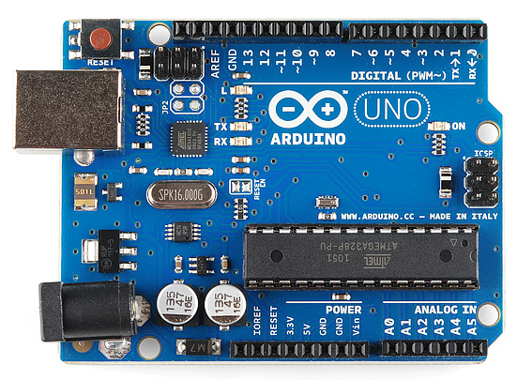

Arduino is a single-board microcontroller to makes victimization physics in multidisciplinary projects more accessible. The hardware consists of a simple open source hardware board designed around an 8-bit Atmel AVR microcontroller or a 32-bit Atmel ARM. The code consists of a typical programming language compiler and a boot loader that executes on the microcontroller.

**Hardware Specifications:**

• Microcontroller: ATmega328

• Operating Voltage: 5V

• Input Voltage(recommended):7-12V

• Input Voltage (limits): 6-20V

• Digital I/O Pins: 14 (of which 6 provide PWM output)

• Analog Input Pins: 6

• DC Current per I/O Pin: 40mA

• DC Current for 3.3V Pin: 50mA

• Flash Memory: 32 KB(ATmega328)

• SRAM: 2 KB (ATmega328)

• EEPROM: 1 KB (ATmega328)

• Clock Speed: 16 MHz

**NodeMCU v2:**

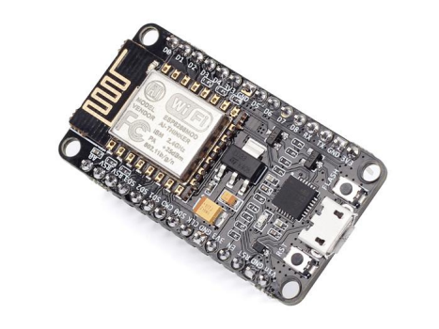

The NodeMcu is an open-source firmware and development kit that helps you to Prototype your IOT product within a few Lua script lines.

**Features:**

∙ Open-source

∙ Interactive

∙ Programmable

∙ Low cost

∙ Simple

∙ Smart

∙ WI-FI enabled

**Arduino-like hardware IO:**

Advanced API for hardware IO, which can dramatically reduce the redundant work for configuring and manipulating hardware. Code like Arduino, but interactively in Lua script.

**Nodejs style network API:**

Event-driven API for network applications, which facilitates developers writing code running on a 5mm*5mm sized MCU in Nodejs style.  Greatly speed up your IOT application developing process.

**Specification:**

The Development Kit based on ESP8266, integrates GPIO, PWM, IIC, 1-Wire and ADC all in one board. Power your development in the fastest way combination with NodeMCU Firmware!

∙ USB-TTL included, plug & play

∙ 10 GPIO, every GPIO can be PWM, I2C, 1-wire

∙ FCC CERTIFIED WI-FI module（Coming soon）

∙ PCB antenna

# LCD DISPLAY:

# 

The term [LCD stands for liquid crystal display](https://www.elprocus.com/difference-alphanumeric-display-and-customized-lcd/). It is one kind of electronic display module used in an extensive range of applications like various circuits & devices like mobile phones, calculators, computers, TV sets, etc. These displays are mainly preferred for multi-segment [light-emitting diodes](https://www.elprocus.com/light-emitting-diode-led-working-application/) and seven segments. The main benefits of using this module are inexpensive; simply programmable, animations, and there are no limitations for displaying custom characters, special and even animations, etc.

### **Features of LCD16x2:**

The features of this LCD mainly include the following.

* The operating voltage of this LCD is 4.7V-5.3V
* It includes two rows where each row can produce 16-characters.
* The utilization of current is 1mA with no backlight
* Every character can be built with a 5×8 pixel box
* The alphanumeric LCDs alphabets & numbers
* Is display can work on two modes like 4-bit & 8-bit
* These are obtainable in Blue & Green Backlight
* It displays a few custom generated characters

**GSR sensor:**

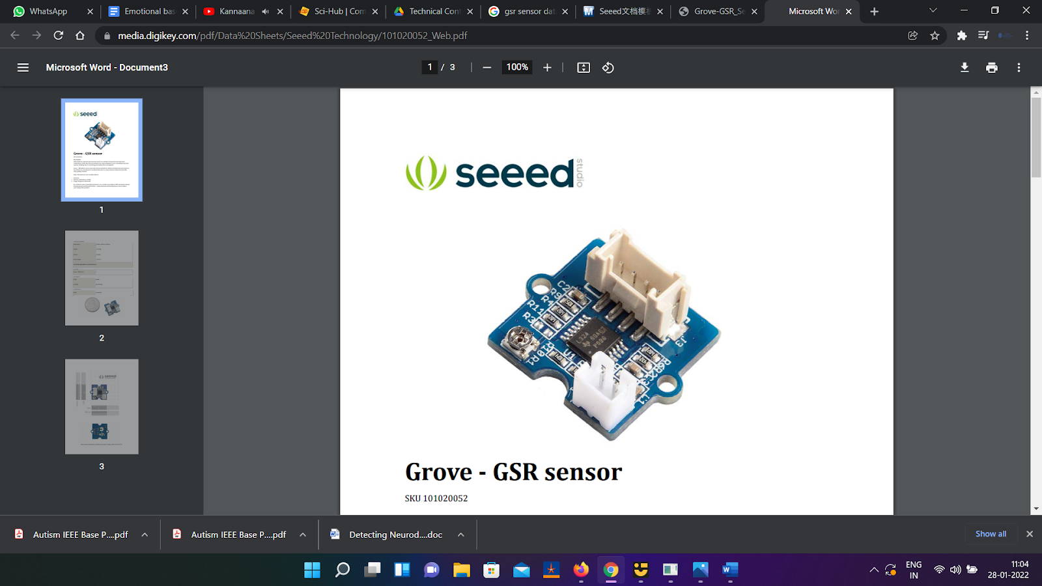

GSR stands for galvanic skin response and it's a way of measurement the electrical electrical phenomenon of the skin. Robust emotions will cause input to your sympathetic systema nervosum, ensuing additional sweat being secreted by the sweat glands. Grove ‐ electrodermal response permits you to identify such robust emotions by merely attaching 2 electrodes to 2 fingers on one hand. It's a stimulating gear to make feeling connected comes like sleep quality monitor.

**Features:**

* Detects conductance of skin.
* Finger Straps for electrodes For all Grove users (especially beginners),
* Technical Details: Dimensions 24mm x 20mm x 9.80mm
* Weight G.W 29g, Battery Exclude Input Voltage 5V/3.3V
* Sensitivity adjustable via a potentiometer

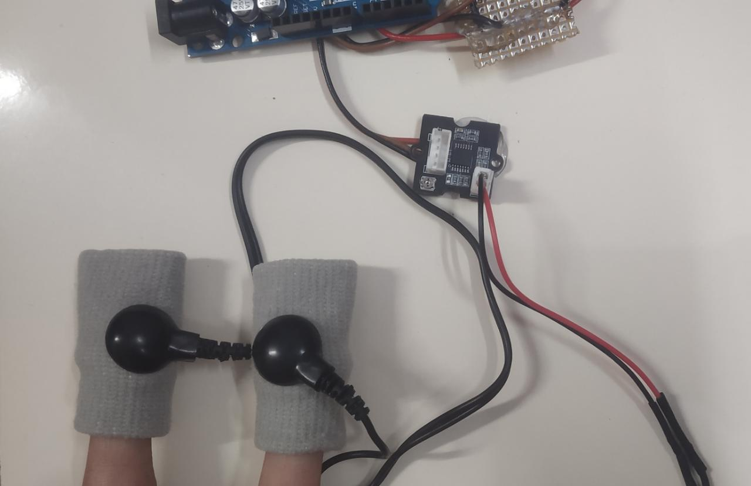

**3.5 SOFTWARE ENVIRONMENT**

**Domain-Machine Learning**

Deep learning is an [artificial intelligence (AI)](https://www.investopedia.com/terms/a/artificial-intelligence-ai.asp) function that imitates the workings of the human brain in processing knowledge and making patterns to be used in higher cognitive processes. Deep learning is a subset of [machine learning](https://www.investopedia.com/terms/m/machine-learning.asp) in artificial intelligence that has networks capable of unattended from knowledge that's unstructured or unlabeled. It’s conjointly referred to as deep neural learning or deep neural network.

**Front end**-Python 3.8

# OpenCV

* **NumPy**
* **Keras**

**OpenCV**

OpenCV-Python is a library of Python bindings designed to solve computer vision problems. It makes use of Numpy, which is a highly optimized library for numerical operations with MATLAB-style syntax. All the OpenCV array structures are converted to and from Numpy arrays. It is nothing but a wrapper class for the original C++ library to be used with Python. Using this, all of the OpenCV array structures get converted to/from NumPy arrays. This makes it easier to integrate it with other libraries which use NumPy. For example, libraries such as SciPy and Matplotlib. It is an open-source computer vision and machine learning software library. It was built to provide a common infrastructure for computer vision applications and to accelerate the use of machine perception in the commercial products.

# NumPy

NumPy is, just like SciPy, Scikit-Learn, Pandas, etc. one of the packages which cannot be missed while learning data science, mainly because this library provides an array data structure that holds some benefits over Python lists, such as: being more compact, faster access in reading and writing items, being more convenient and more efficient. To make a numpy array, np.array() function is used.

**Keras**

Keras is an open-source neural-network **library** written in **Python**. It is capable of running on top of Tensor Flow, Microsoft Cognitive Toolkit, R, The a no, or Plaid ML. Designed to enable fast experimentation with deep neural networks, it focuses on being user-friendly, modular, and extensible. It is developed using four guiding principles:

1. **Modularity**: A model can be understood as a sequence or a graph alone. All the concerns of a deep learning model are discrete components that can be combined in arbitrary ways.
2. **Minimalism**: The library provides just enough to achieve an outcome, no frills and maximizing readability.
3. **Extensibility**: New components are intentionally easy to add and use with in the framework, intended for researchers to trial and explore new ideas.
4. **Python**: No separate model files with custom file formats. Everything is native Python.

**Backend**-TENSORFLOW2.0

Tensor Flow is an end-to-end open-source platform for deep learning. It has a comprehensive, flexible ecosystem of tools, libraries, and community resources that lets researchers push the state-of-the-art in deep learning and developers easily build and deploy deep learning-powered applications. It is a general-purpose high-performance computing library open-sourced by Googlein2015. From the beginning, its main focus was to provide high-performance APIs for building Neural Networks (NNs). However, with the advance of time and interest by the Deep learning community, the lib has grown to a full deep learning ecosystem.

**CHAPTER – 4**

**SYSTEM DESIGN**

**4.1 ER DIAGRAM**

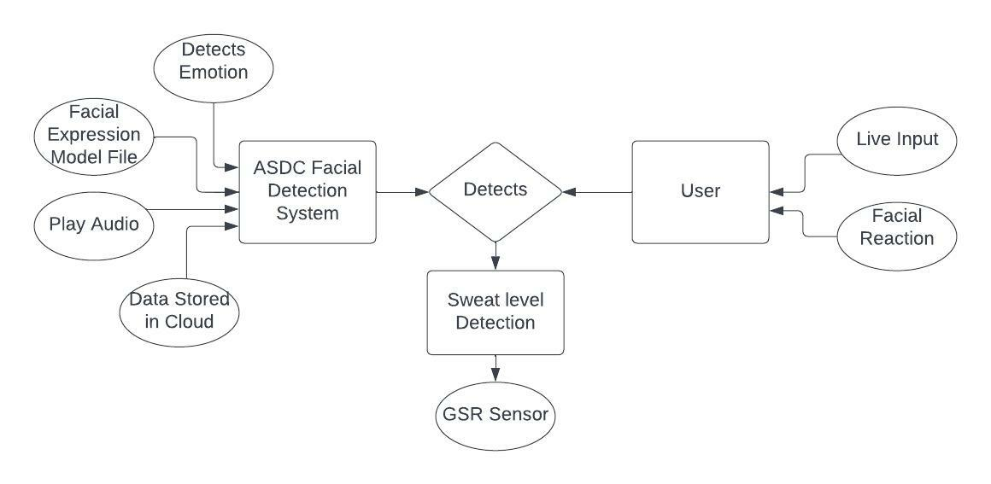

Figure 4.1 ER Diagram

**4.2 DATA DICTIONARY**

|  |  |  |
| --- | --- | --- |
| created_at | entry_id | Gsr |
| 2022-05-10T11:37:21+05:30 | 1 | 100 |
| 2022-05-10T11:37:50+05:30 | 2 | 56 |
| 2022-05-10T11:38:19+05:30 | 3 | 10 |
| 2022-05-10T11:38:49+05:30 | 4 | 100 |
| 2022-05-10T15:06:30+05:30 | 5 | 0 |
| 2022-05-10T15:06:58+05:30 | 6 | 0 |
| 2022-05-10T15:07:27+05:30 | 7 | 52 |
| 2022-05-10T15:07:56+05:30 | 8 | 0 |
| 2022-05-10T15:08:24+05:30 | 9 | 0 |
| 2022-05-10T15:08:53+05:30 | 10 | 53 |
| 2022-05-10T15:09:22+05:30 | 11 | 100 |
| 2022-05-10T15:09:50+05:30 | 12 | 100 |
| 2022-05-10T15:10:19+05:30 | 13 | 100 |
| 2022-05-10T15:10:48+05:30 | 14 | 100 |
| 2022-05-10T15:11:17+05:30 | 15 | 0 |
| 2022-05-10T15:11:46+05:30 | 16 | 49 |
| 2022-05-10T15:12:15+05:30 | 17 | 54 |
| 2022-05-10T15:12:44+05:30 | 18 | 61 |
| 2022-05-10T15:13:14+05:30 | 19 | 61 |
| 2022-05-10T15:13:43+05:30 | 20 | 64 |
| 2022-05-10T15:14:11+05:30 | 21 | 64 |
| 2022-05-10T15:14:41+05:30 | 22 | 64 |
| 2022-05-10T15:15:10+05:30 | 23 | 66 |
| 2022-05-10T15:15:38+05:30 | 24 | 0 |
| 2022-05-10T15:16:07+05:30 | 25 | 0 |
| 2022-05-10T15:16:35+05:30 | 26 | 0 |
| 2022-05-10T15:17:04+05:30 | 27 | 0 |
| 2022-05-10T15:17:32+05:30 | 28 | 0 |
| 2022-05-10T15:18:01+05:30 | 29 | 0 |
| 2022-05-10T15:18:29+05:30 | 30 | 0 |

Figure 4.2 Data Dictionary

**4.3 DATA FLOW DIAGRAM**

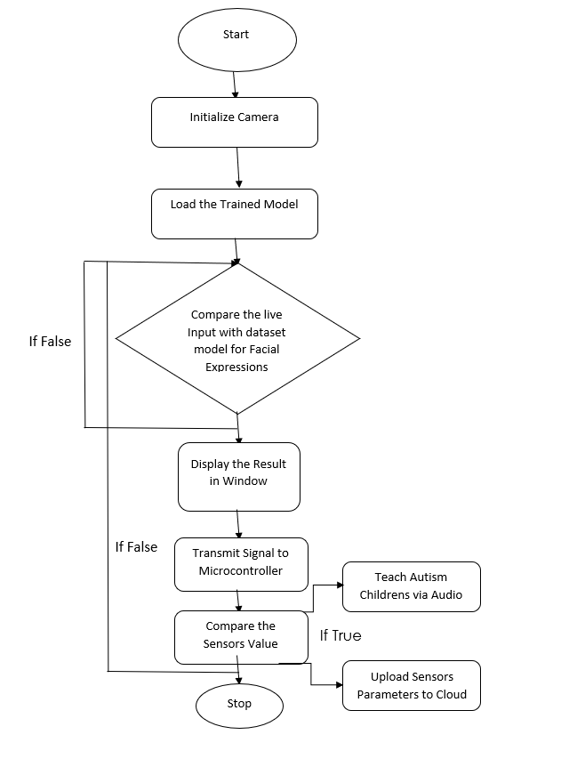

Figure 4.3 Data Flow Diagram

**4.4 UML Diagram**

# 4.4.1 Use Case Diagram

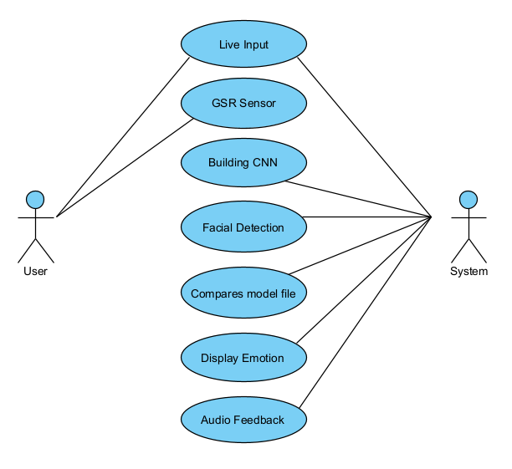

Figure 4.4 Use Case Diagram

**4.4.2 Activity Diagram**

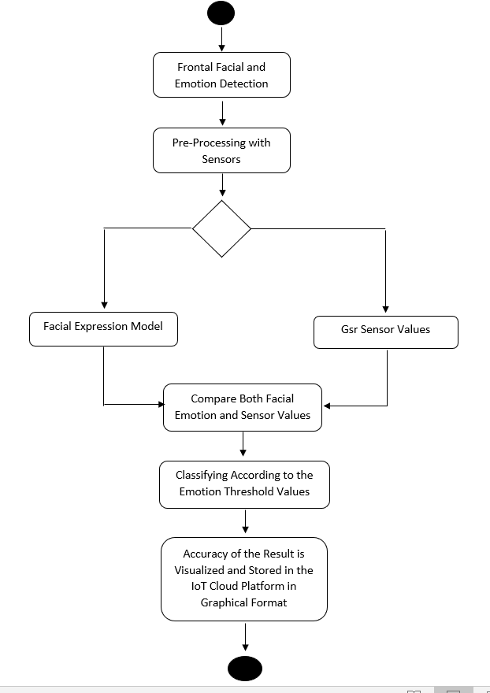

Figure 4.4 Activity Diagram

# 4.4.3 Class Diagram

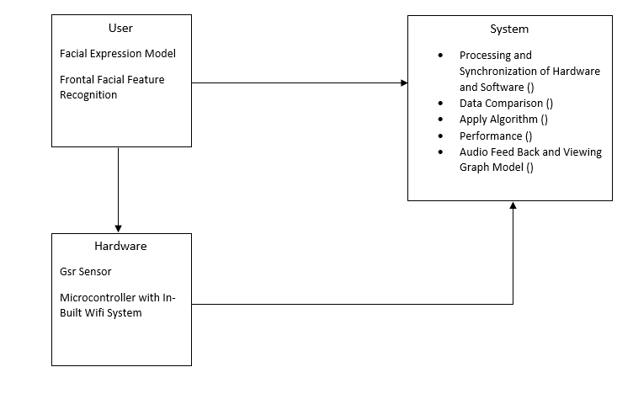

Figure 4.4 Class Diagram

**4.4.4 Sequence Diagram**

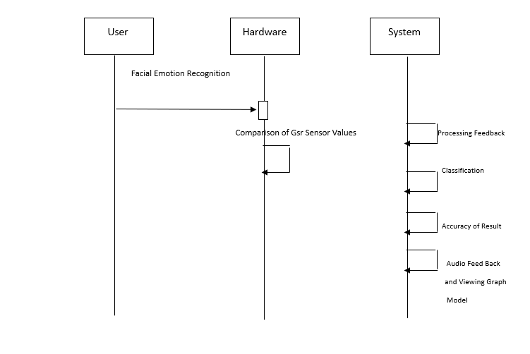

Figure 4.4 Sequence Diagram

**CHAPTER – 5**

**SYSTEM ARCHITECTURE**

# Architecture Overview

**Overview of the Project:**

This Project is divided into two sectors one is the software part and another is the Hardware Part.

**Explanation:**

The Project will be Using a Convolution Neural network Algorithm to detect the Facial Emotion and by using the Trained Model we will be identifying the Emotion by comparing the Image of the Live Input with the Model file and then based on the Emotion we will Train them by playing Rhymes when their Emotion is Happy and we are also using Hardware part as Mental Health is very Important to everyone we will be using Galvanic Skin Response Sensor where Electrodes is Connected to the Subject and Based on the Threshold Values we will storing the Data in the Cloud Platform which becomes very useful for the Parents or Care taker to analyse their Mental Space as well. The reason of Focusing both these aspects are they might have possible anxiety with mingled with crowd, and By Analysing the Facial Emotion we can also help them learn things, we believe technology should reach all medium of users and will help them overcome their problems.

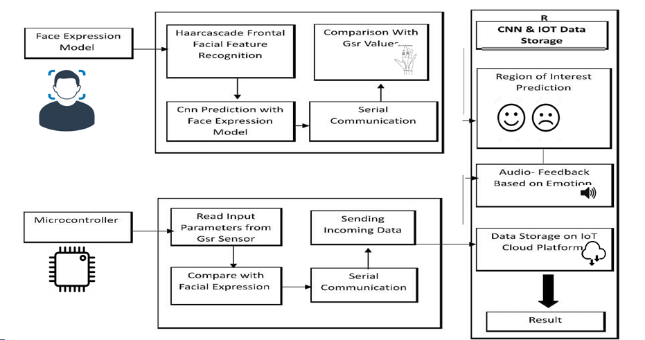

Figure 5 System architecture

# 5.1 MODULE DESIGN SPECIFICATION :

**Exploring the Dataset**

From Kaggle open resource, we had a **training** dataset, a **public test** dataset (which is then used as a validation dataset for our project), and further a **private test** dataset (same size as the public test dataset and will be used as data for evaluating the prediction performance). Image set of 35,887 examples, with training-set : **80%** validation-set : **10%** test-set : **10%**.

# 

# Steps in involved:

* Initiate CV
* Resizing
* Comparison
* Audio Feedback
* Data storage on Cloud

**Haar Cascades**

A sequence of rescaled “square-shaped” functions along with kind of a moving ridge family or basis. it's supported the Haar moving ridge technique to analyze pixels within the image into squares by operation. This uses machine learning techniques to urge a high degree of accuracy from what's known as “training data”. This uses “integral image” ideas to cipher the “features” detected. Haar Cascades uses the Adaboost learning algorithmic program that selects a tiny low range of necessary options from an oversized set to relinquish Associate in Nursing economical results of classifiers.

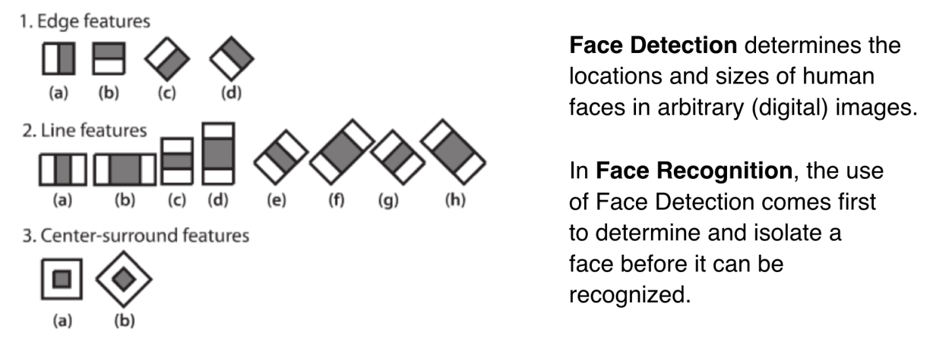

Figure 5.1 Haar Cascade

This is a quick illustration of options Extraction and therefore the distinction between Face Detection and Face Recognition. Face detection is regarding locating, whereas face recognition is regarding distinguishing.

**Steps:**

* The main concept used to predict the Emotion of Autism children’s and Play Music’s based on their Emotions. The flow of the project is as follows:
* First using read the image from the Camera by using OpenCV
* Then, the haar cascade method is used to detect faces in each frame of the webcam feed.
* The region of the image containing the face is resized to 48x48 and is passed as input to the CNN.
* The feeling with the maximum score is displayed on the screen.
* Based on the Emotion Audio Will be played.

**Feature Extraction**

Haar Cascades uses machine learning techniques in which a function is trained from a lot of positive and negative images. This process in the algorithm is feature extraction.

In feature extraction, the algorithm uses training data to best identify features that it can consider a face. The training data used in this project is an XML file called: haarcascade_frontalface_default.xml

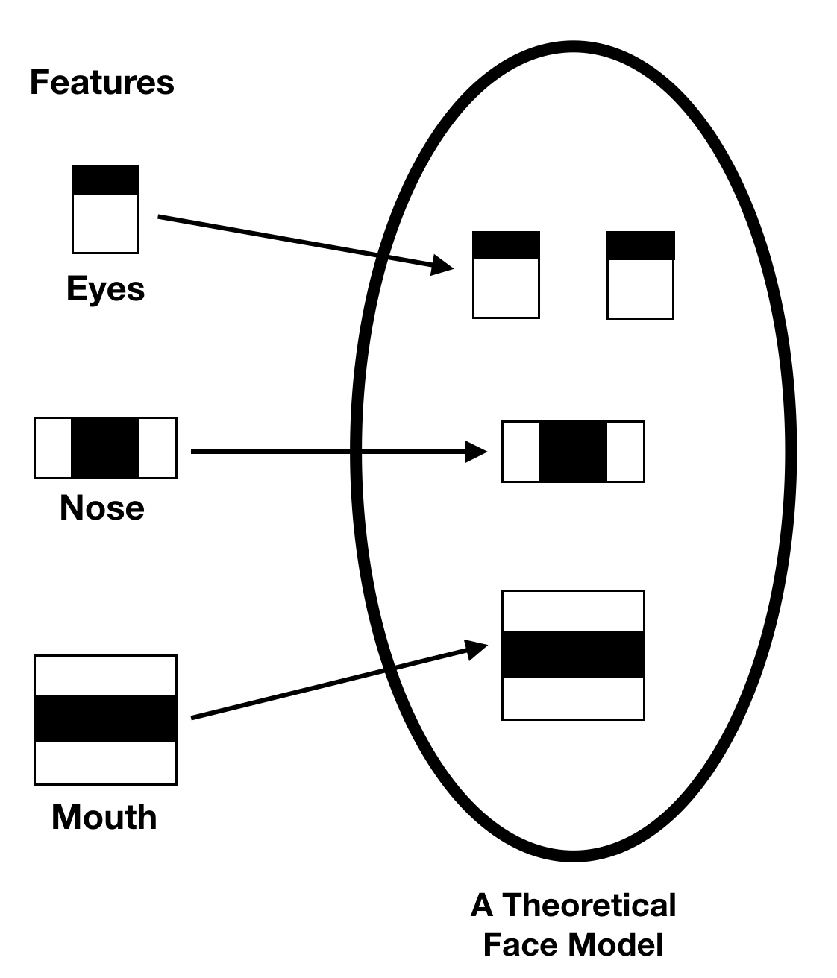

Figure 5.2 Feature Extraction

# CNN(Convolutional Neural Network)Classification

* CNNs are a class of Deep Neural Networks that can recognize and classify particular features from pictures and are widely used for analyzing visual images.
* There are used widely in the medical image analysis.
* The term ‘Convolution” in CNN denotes that two images can be represented as **matrices** which are multiplied to give an output that is used to extract features from the image.

 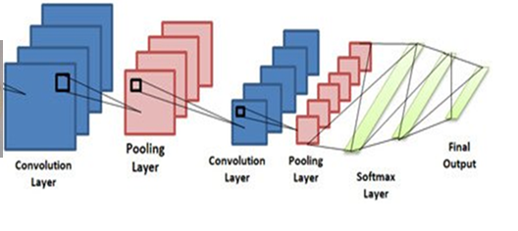

Figure 5.3 CNN

# Layers of CNN

1. **Input Layer**

Input layer generally represents the pixel matrix of the image and brings the initial data into the system for further processing by subsequent layers.

1. **\*Convolutional Layer**

This **layer** performs task referred to as “**convolution**”. The convolutional **layer** is **employed** to extract image features and a filter of a selected size M x M. The dot product is taken between the filter and also the components of the input image with regard to the dimensions of the filter (M x M). The total of those dot products is employed to supply the output image that is fed as input to the next layer

1. **Pooling Layer**

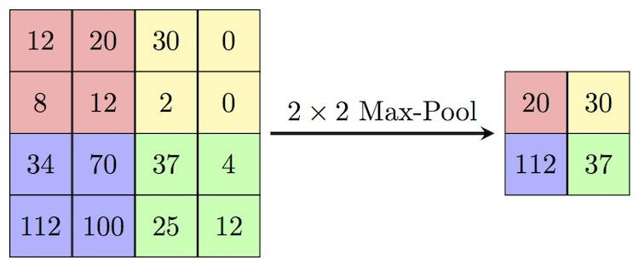**Pooling** layer is obtained by applying the pooling operator to mixture data at intervals every little region of input feature channels so down sampling the results. Used to reduce the dimensions of the feature maps. Thus, it reduces the number of parameters to learn.

Figure 5.4 Pooling layer

1. **Fully-Connected Layer**

Fully connected layers connect each somatic cell in one layer to each somatic cell in another layer. The output layer is answerable for manufacturing the ultimate result. There should be one output layer during a neural network. The output layer takes within the inputs that are passed in from the layers before it, performs the calculations via its neurons and so the output is computed.

# Output Layer

The output layer is answerable for producing the final result. There should be atleast one output layer in a neural network. The output layer takes in the inputs which are passed in from the previous layers, performs the calculations via its neurons then the output is

**Soft max Function**

The soft max function is used as the activation function in the output layer of neural network models that predict a multinomial probability distribution. That is, soft max is used as the activation function for multi-class classification problems where class membership is required on more than two class labels. The final output is calculated using soft max which gives the probability of each class for given features.

# Training

The sample data is used to fit the model the actual dataset that was used to train the model(weights and biases in the case of CNN). The model sees and learns from this data. A number of recommended approaches in the tool kit that could be experimented with,

* Weight Initialization.
* Learning Rate.
* Activation Functions.
* Network Topology.
* Batches and Epochs.
* Regularization.
* Optimization and Loss.
* Early Stopping.

# Testing

The dataset contains a test folder and in a test.csv file, the details related to the image path and the irrespective class labels are specified. The image path and labels are extracted using pandas. Then to predict the model, the images are resized to30×30 pixels and a numpy array containing all image data is made. From the skin learn. metrics, the confusion matrix is imported and observed how the model predicted the actual labels. A result, 95% accuracy of the model is achieved.

# Confusion Matrix

A confusion matrix is a table that is often used to describe the performance of a classification model (or "classifier") on a set of test data for which the true values are known. A Confusion matrix is an associate N x N matrix used for evaluating the performance of a classification model, where N is the number of target classes. The matrix compares the actual particular values with those expected by the machine learning model.

# 5.2 ALGORITHM

# Initial Setup

1. Install Arduino , python idle and things view application.
2. Create account in thingspeak for both admin and users .

# Input Procedure

# Import packages and library files.

# Import cv2, tensorflow, FacialExpressionModel, num, time, serial, audio player

# Connect the Arduino by plugging A to B cable into the PC.

# Open main.py file in python idle and run it.

# Sit in front of the camera.

# Wear the GSR sensor bands to your fingers.

# Output Procedure

1. Open Thingspeak mobile application and connect with channel number.

2. Run the main.py file.

# 3. Output Terminal and camera opens.

# 4. Face will be detected in camera using haar cascade and CNN.

# 5. GSR sensor will pass values according to their sweat conductance.

# 6. Based on GSR and face detected value audio will play.

# 7. Data is stored in cloud

**CHAPTER – 6**

**SYSTEM IMPLEMENTATION**

**6.1 CODING**

Main.py

import cv2

import tensorflow

from Models.model import FacialExpressionModel

import numpy as np

import time

import serial

from audioplayer import AudioPlayer

rgb = cv2.VideoCapture(0)

facec = cv2.CascadeClassifier('Models/haarcascade_frontalface_default.xml')

font = cv2.FONT_HERSHEY_SIMPLEX

found = set()

arduinoData = serial.Serial('COM3', 115200)

readdat=""

def getSeriAl():

global DaTa_r

global gsr_r

global stat

if(arduinoData.in_waiting >0):

line = arduinoData.readline()

readdat=line.decode()

#print(readdat)

if(readdat == "Ready\r\n"):

print("Device online")

arduinoData.write('PyreC$'.encode())

if(readdat == "GSR:\r\n"):

line = arduinoData.readline()

readdat=line.decode()

gsr_r=readdat

#print(readdat)

print(readdat)

else:

readdat=""

def __get_data__():

"""

__get_data__: Gets data from the VideoCapture object and classifies them

to a face or no face.

returns: tuple (faces in image, frame read, grayscale frame)

"""

_, fr = rgb.read()

fr=cv2.flip(fr,1)

gray = cv2.cvtColor(fr, cv2.COLOR_BGR2GRAY)

faces = facec.detectMultiScale(gray, 1.3, 5)

return faces, fr, gray

def start_app(cnn):

count_h=0

count_s=0

count_n=0

while True:

global gsr_r

getSeriAl()

print("gsr: ",gsr_r)

faces, fr, gray_fr = __get_data__()

for (x, y, w, h) in faces:

time.sleep(0.2)

fc = gray_fr[y:y+h, x:x+w]

roi = cv2.resize(fc, (48, 48))

pred = cnn.predict_emotion(roi[np.newaxis, :, :, np.newaxis])

cv2.putText(fr, pred, (x, y), font, 1, (255, 255, 0), 2)

cv2.rectangle(fr,(x,y),(x+w,y+h),(255,0,0),2)

if(str(pred)=='Happy' ):

count_h+=1

count_s=0

print("Happy ",count_h)

if(count_h>=5 and (int(gsr_r)>0 and int(gsr_r) <80)):

arduinoData.write('Happy$'.encode())

AudioPlayer("rhy.mp3").play(block=True)

arduinoData.write('PyreC$'.encode())

count_h=0

elif(count_h>5 and (int(gsr_r)==0 or int(gsr_r)> 80)):

count_h=0

arduinoData.write('PyreC$'.encode())

elif(str(pred)=='Sad' ):

count_s+=1

count_h=0

print("Sad ",count_s)

if(count_s>=5 and int(gsr_r)>80):

arduinoData.write('Sad$'.encode())

AudioPlayer("rhythmic_clapping.wav").play(block=True)

arduinoData.write('PyreC$'.encode())

count_s=0

elif(count_s>5):

count_s=0

arduinoData.write('PyreC$'.encode())

else:

count_n+=1

count_s=0

count_h=0

if(count_n>=5):

count_n=0

arduinoData.write('PyreC$'.encode())

if cv2.waitKey(1) == 27:

break

cv2.imshow('Emotion Based Teaching', fr)

cv2.destroyAllWindows()

gsr_r=0

getSeriAl()

if __name__ == '__main__':

model = FacialExpressionModel("Models/face_model.json","Models/face_model.h5")

start_app(model)

**BTEC898_Node**

#include <ESP8266WiFi.h>

#include <SoftwareSerial.h>

#include "ThingSpeak.h"

#define RX D5

#define TX D6

SoftwareSerial ard_node(RX, TX, false, 256);

//SoftwareSerial ard_node;

int a, b;

char ssid1[] = "Project";

char password1[] = "1234567890";

unsigned long channelID = 1729769;

const char * writeAPIKey = "SKVCXY2A632JI8T3"; // write API key for your ThingSpeak Channel

const char* server = "api.thingspeak.com";

String th;

int gsr_r;

String prev_Rec = "Neutral";

int tup = 20;

WiFiClient client;

void setup() {

// put your setup code here, to run once:

Serial.begin(115200);

ard_node.begin (115200);

// ard_node.begin (115200, SWSERIAL_8N1, RX, TX, false, 256);

setupWifi();

ThingSpeak.begin(client);

}

void setupWifi() {

Serial.println();

Serial.println();

Serial.print(ssid1);

WiFi.begin(ssid1, password1);

Serial.print("Connecting to ");

while (WiFi.status() != WL_CONNECTED)

{

delay(800);

Serial.print(".");

}

Serial.println("");

Serial.println("WiFi connected");

Serial.println("IP address: ");

Serial.println(WiFi.localIP());

delay(1000);

}

void loop() {

getArd();

UpdateServer();

delay(100);

}

void getArd() {

String SS = ""; String SSs = "";

while (ard_node.available() > 0) {

char S = ard_node.read();

SS += S;

// Serial.println(SS);

delay(10);

}

if (SS.length() > 0) {

Serial.println(SS);

String gs = getSplitValue(SS , ',', 0);

String emo = getSplitValue(SS , ',', 1);

gsr_r = gs.toInt();

prev_Rec = String(emo);

ard_node.flush();

}

}

void UpdateServer() {

tup++;

if (tup >= 250) {

if (client.connect(server, 80)) {

ThingSpeak.setField(1, String(gsr_r));

ThingSpeak.setField(2, String(prev_Rec));

int x = ThingSpeak.writeFields(channelID, writeAPIKey);

if (x == 200) {

Serial.println("Channel update successful.");

}

else {

Serial.println("Problem updating channel. HTTP error code " + String(x));

}

}

tup = 0;

}

}

**BTEC898_Master**

#include<LiquidCrystal.h>

#include <SoftwareSerial.h>

#define splash splash1

#define python Serial

#define RX 3

#define TX 2

SoftwareSerial ard_node(RX, TX);

LiquidCrystal lcd(13, 12, 11, 10, 9, 8);

#define gsr A0

String IncomingData = "";

int gsr_r;

int dis_t = 550;

int disp = dis_t ;

int py_send = 0;

String prev_Rec = "Neutral";

void setup() {

// put your setup code here, to run once:

Serial.begin(115200);

ard_node.begin(115200);

python.begin(115200);

LcDSet();

splash(0, "Initializing");

splash(1, "Python");

delay(8000);

python.println("Ready");

lcd.clear();

}

void LcDSet() {

lcd.begin(16, 2);

splash(0, "Emotion Based");

splash(1, "Teaching System");

delay(3000);

splash(0, "For Autistic");

splash(1, "Children's");

delay(3000);

}

void loop() {

// put your main code here, to run repeatedly:

getSensor();

getPython();

disp++;

// Serial.println(disp);

if (disp > dis_t) {

lcd.setCursor(0, 0);

lcd.print("GSR : ");

lcd.setCursor(5, 0);

lcd.print(gsr_r);

splash(1, "");

if (py_send) {

python.print("GSR:");

python.println();

python.print(gsr_r);

python.println();

}

ard_node.print(gsr_r);

ard_node.print(",");

ard_node.print(prev_Rec);

ard_node.print(",");

Serial.println();

disp = 0;

}

delay(2);

}

void getPython() {

if (python.available())

{

IncomingData = python.readStringUntil('$');

delayMicroseconds(5);

}

if (IncomingData.length() > 0) {

python.println(IncomingData);

splash(1, IncomingData);

if (IncomingData == "PyreC") {

py_send = 1;prev_Rec = "Neutral";

}

if (IncomingData == "PyreS") {

py_send = 0;

}

if (IncomingData == "Sad" )

{

prev_Rec = "Sad"; py_send = 0;

}

else if (IncomingData == "Happy" )

{

prev_Rec = "Happy"; py_send = 0;

}

else if (IncomingData == "Neutral" )

{

prev_Rec = "Neutral";py_send = 1;

}

IncomingData = "";

}

}

void getSensor() {

gsr_r = analogRead(gsr);

gsr_r = map(gsr_r, 0, 1023, 100, 0);

if (gsr_r <= 36) {

gsr_r = 0

**CHAPTER – 7**

**SYSTEM TESTING**

**7.1 PERFORMANCE ANALYSIS**

The Performance of Haar cascade, CNN and GSR Sensor was estimated with classification performance of the Average Received values, Neutral, Happy and Sad. The Performance of having Two Powerful Technologies Machine Learning and Embedded Systems integrated with Internet of Thing platform helps in Providing Rapid Solution to Kids with Autism by playing their Rhymes based on the values received from both GSR Sensor and the Facial Emotion values. In this Experiment we found that using GSR Sensor and Facial Emotion Comparison for Audio Based Feedback for Kids are Compared, Matched and the data are stored correctly and we are getting 95% accuracy on the tested data.

**7.2 RESULTS AND DISCUSSION**

Thus a completely unique methodology to monitor autistic children and find stress levels has been projected and the results are shown as screenshots. The method proposed above uses transform methods and horizontal projection profiles each of that has economical and fast hardware implementation, to not only monitor autistic children but additionally play audio based on their reactions. The audio played is not only based on their facial reaction it compares the GSR value also (sweat conductance).

The GSR values are stored in ThingSpeak application(cloud). Which can be seen by parents and therapists in the form of a graph. It can be downloaded in the form of Excel sheet (.csv) which will be used to detect the mood swings of the child. This system helps to provide non-invasive rehabilitation therapy for childrens with autism.

**CHAPTER – 8**

**CONCLUSION**

**8.1 CONCLUSION AND FUTURE ENHANCEMENTS**

In the proposed System we have Tested Facial Expression using Convolution Neural Network Prediction and comparing the output with a Galvanic Skin Response sensor to analyze the Emotion level of the Kid with ASD (autism spectrum disorder) we were able to predict the Facial Emotion, and compare the values Successfully and providing the system the higher success rate. In the future, we can combine Pulse Rate Sensor and Restless Detection along with a Non-Invasive Therapy system which will help us to analyze in-depth data and by providing them with a non-invasive rehabilitation therapy for Immediate Relief. This can also be upgraded into a Online Learning Platform for Autistic kids. There are various ways we can enhance this project.

**APPENDICES**

**A.1 SAMPLE SCREENSHOTS**

**Hardware components:**

LCD display, Arduino Mega, Node MCU, GSR Sensor, Power Supply

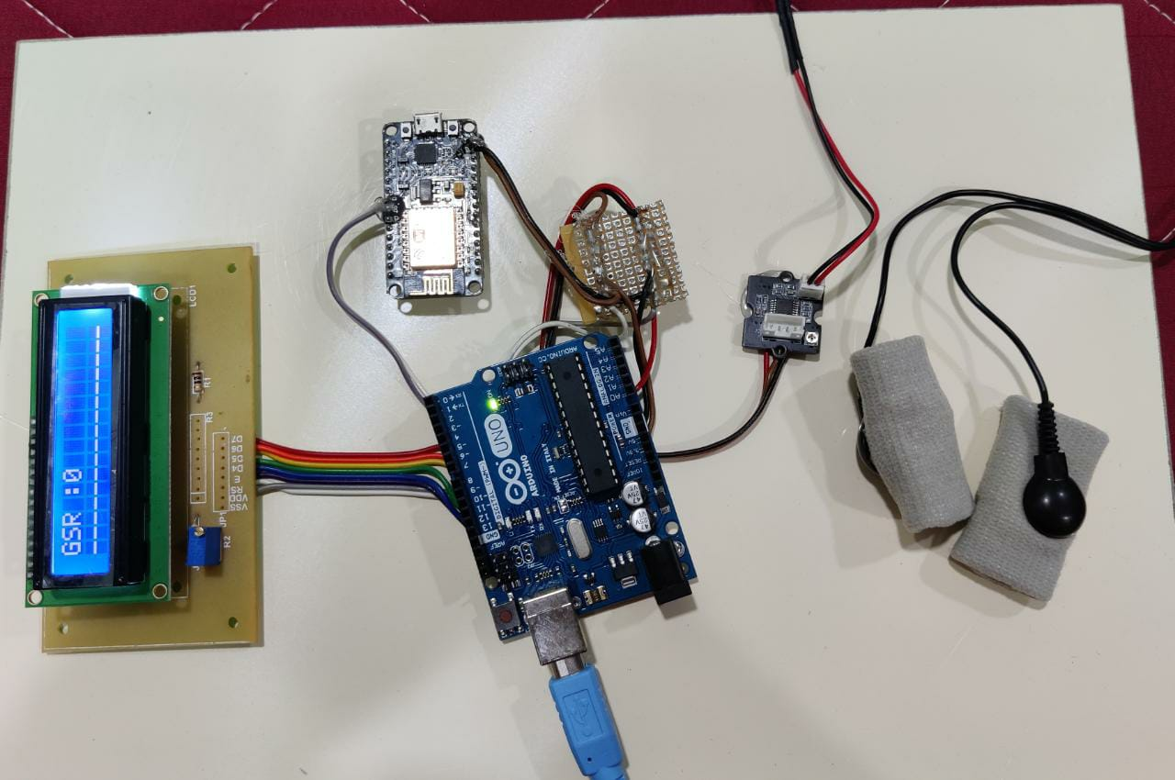

Fig A.1 Hardware Components

**Screen when neutral is predicted:**

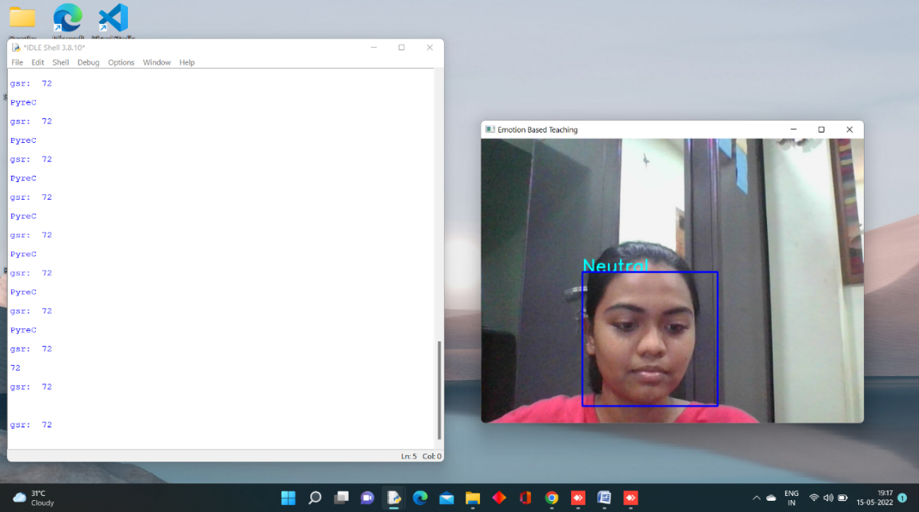

Fig A.2 Screen when neutral is predicted

**Screen when happy is predicted:**

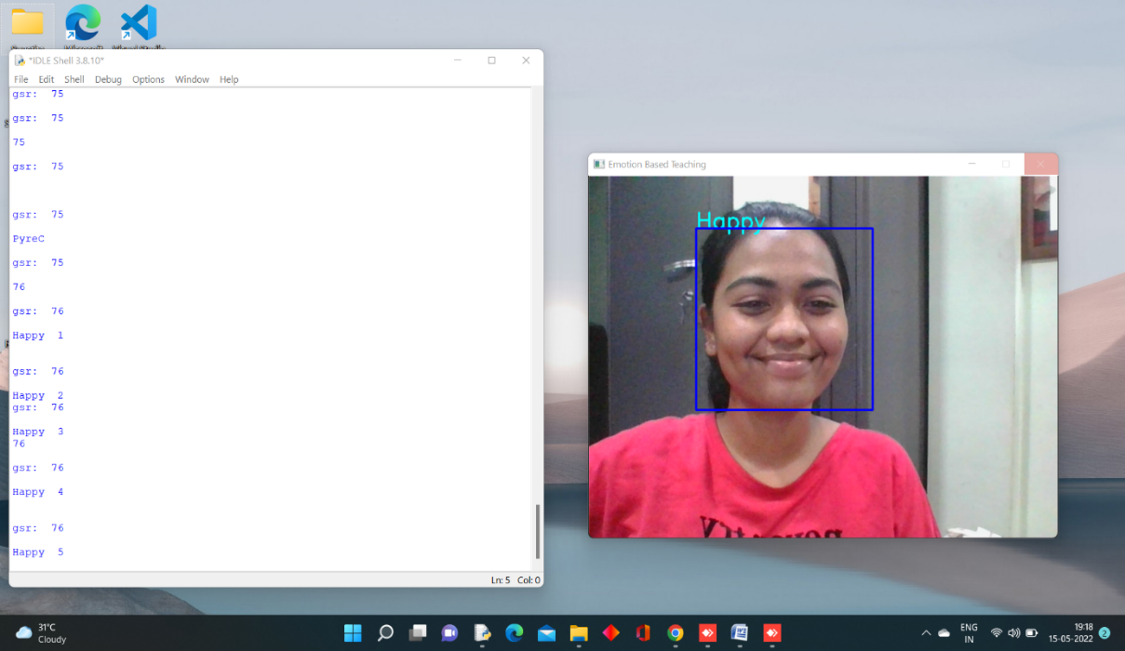

Fig A.3 Screen when happy is predicted

**LCD when happy is predicted:**

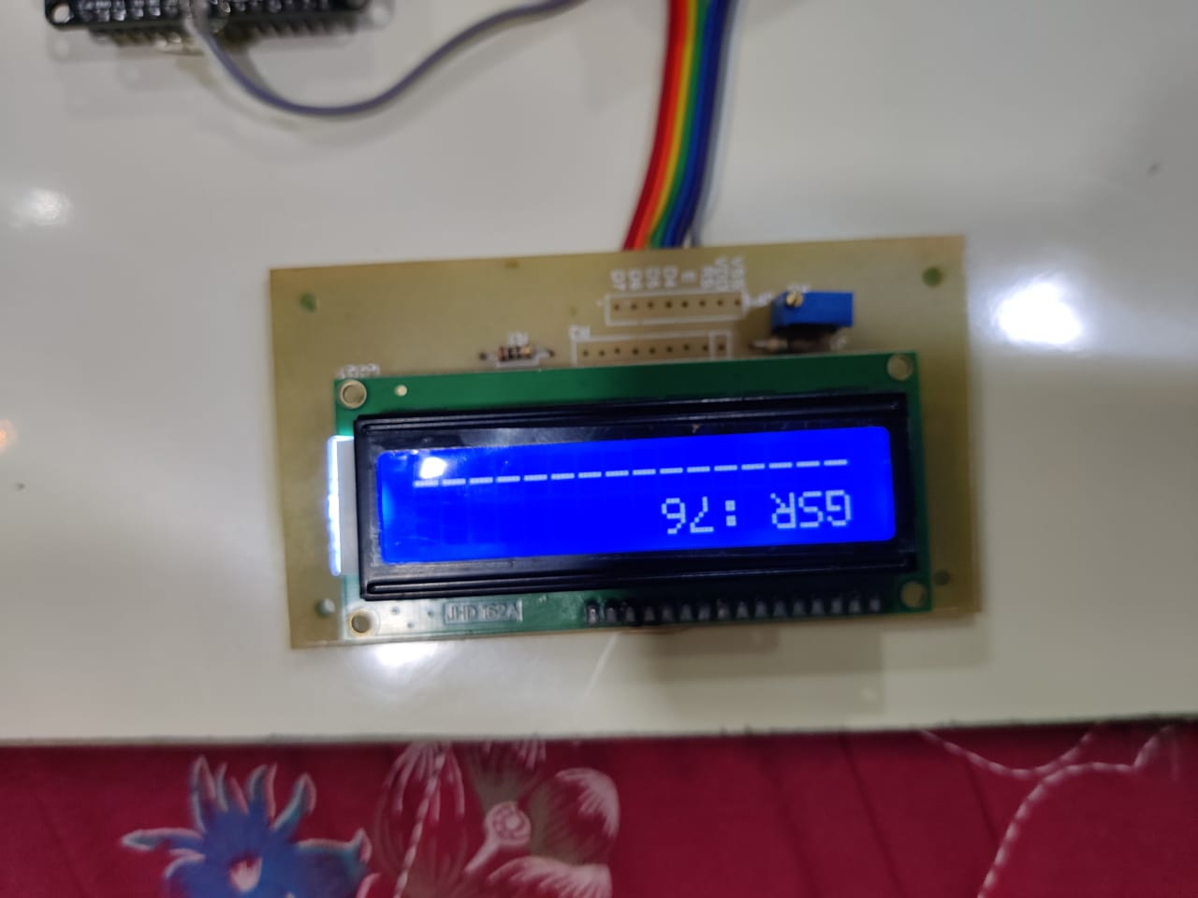

Fig A.4 LCD when happy is predicted

**Screen when sad is predicted:**

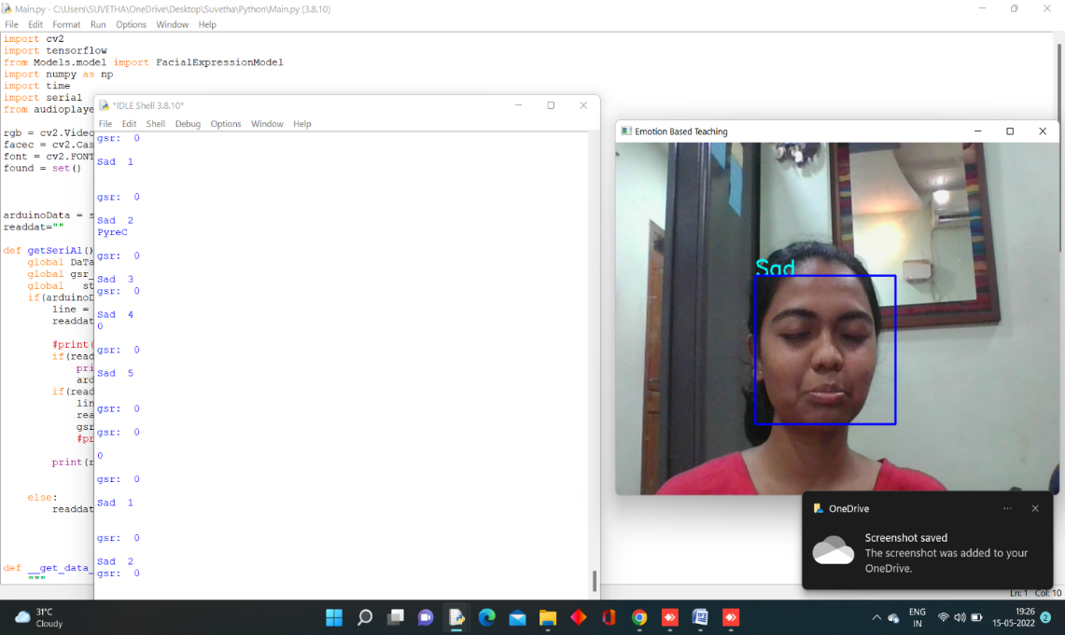

Fig A.5 Screen when sad is predicted

**GSR sensor when sad is predicted:**

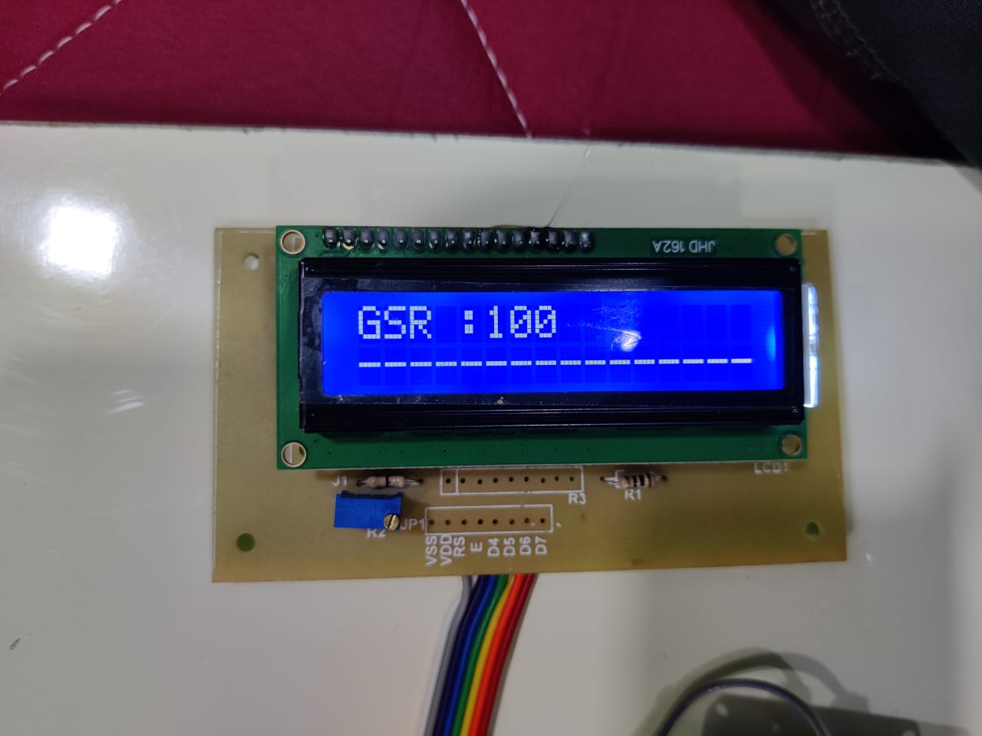

Fig A.6 LCD when sad is predicted

**Screen when surprise is predicted:**

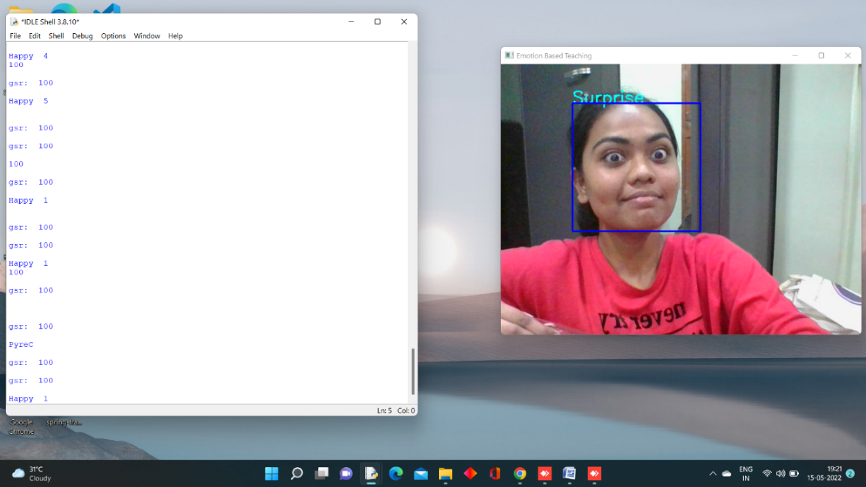

Fig A.7 Screen when suprise is predicted

**Screen when angry is predicted:**

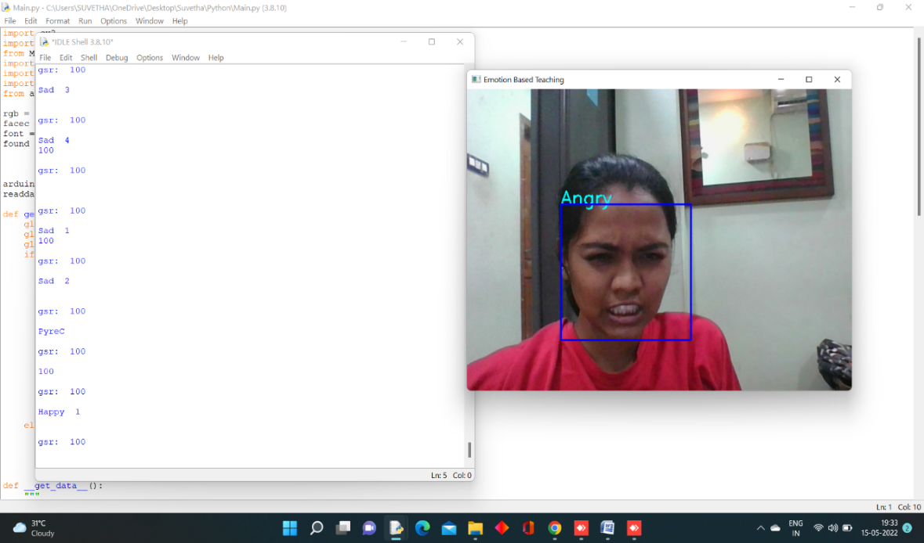

Fig A.8 Screen when Angry is predicted

**Thingspeak application from Admin side:**

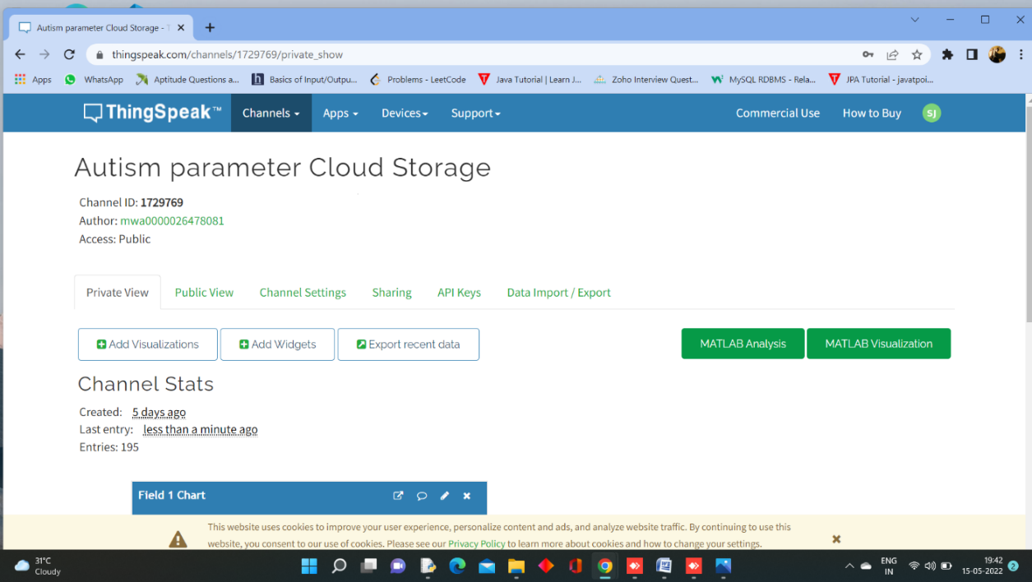

Fig A.9 Thingspeak application from Admin side

**Thingspeak application-Channel settings:**

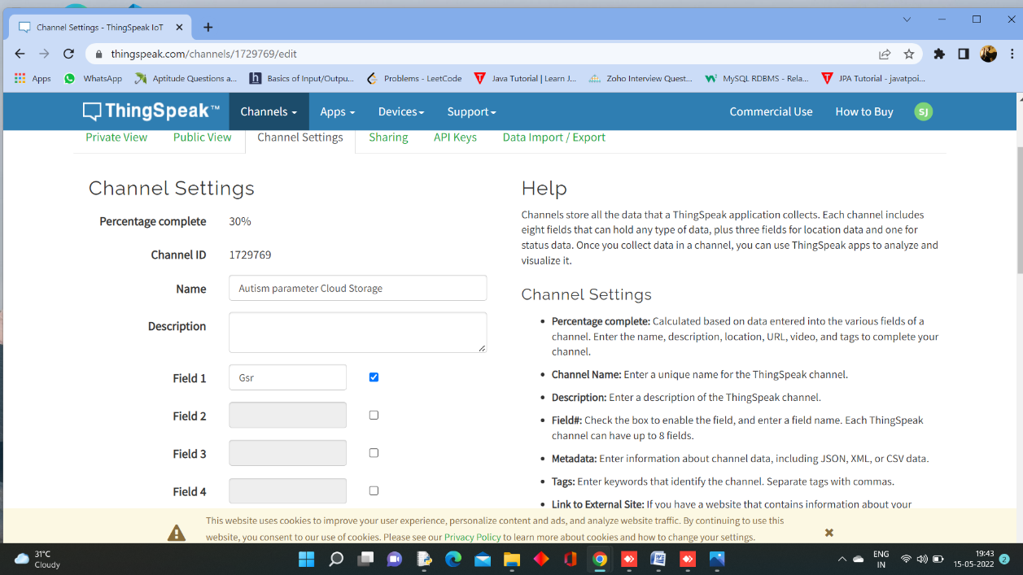

Fig A.10 Thingspeak application-Channel settings

**Thingspeak application-Channel sharing settings:**

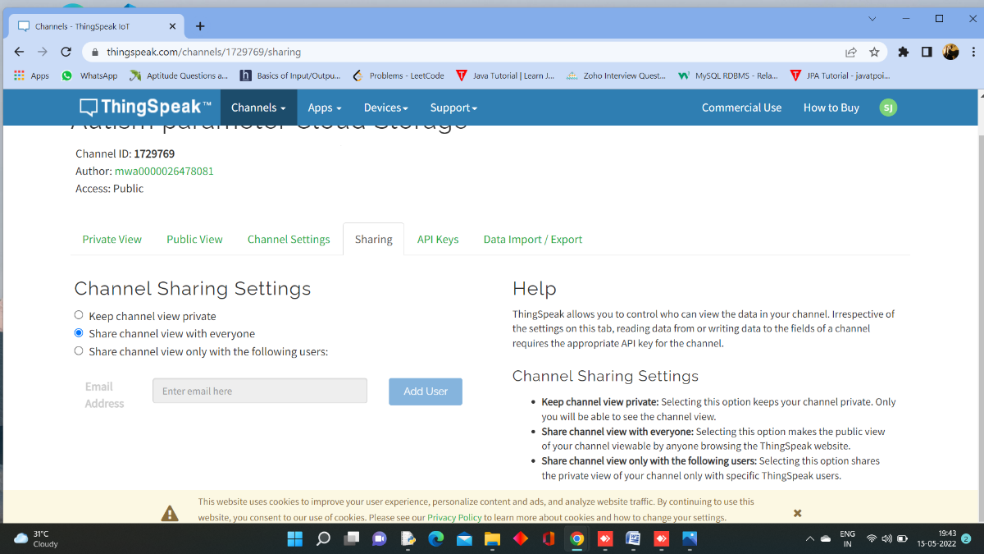

Fig A.11 Thingspeak application-Channel sharing settings

**Thingspeak application-Import Settings:**

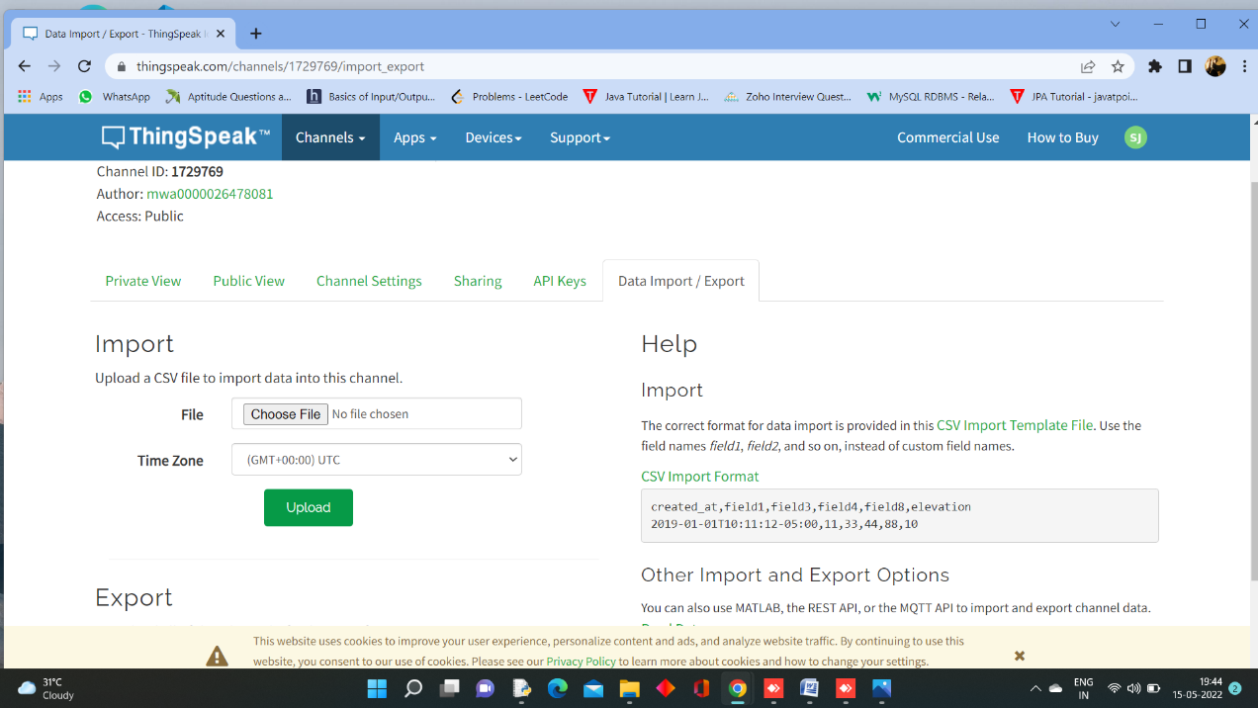

Fig A.12 Thingspeak application-Import settings

**Thingspeak application-Export Settings:**

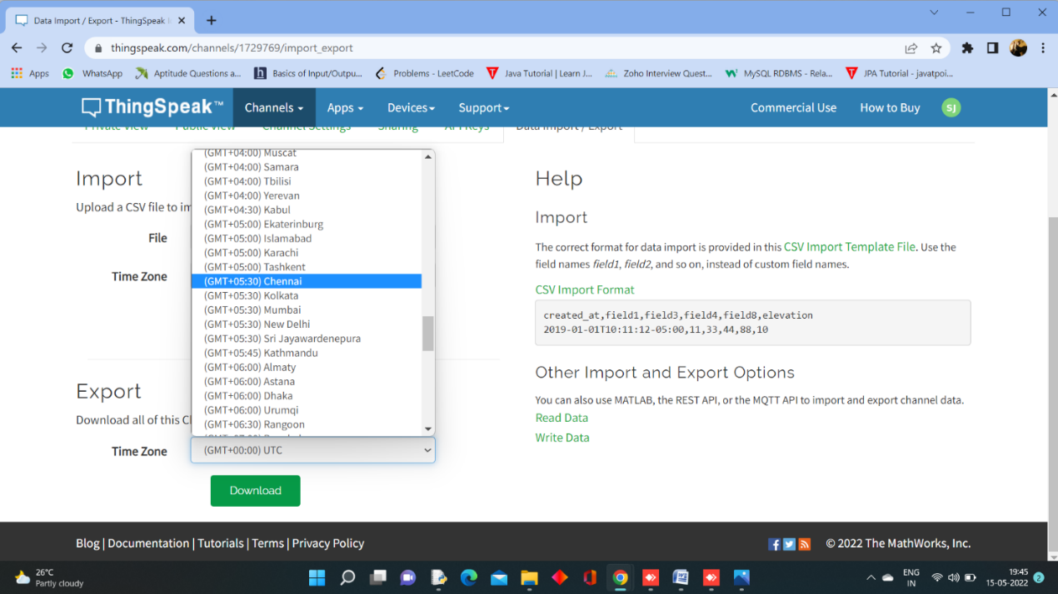

Fig A.13 Thingspeak application-Export settings

**Thingspeak application-Exported data which gets downloaded in .csv form:**

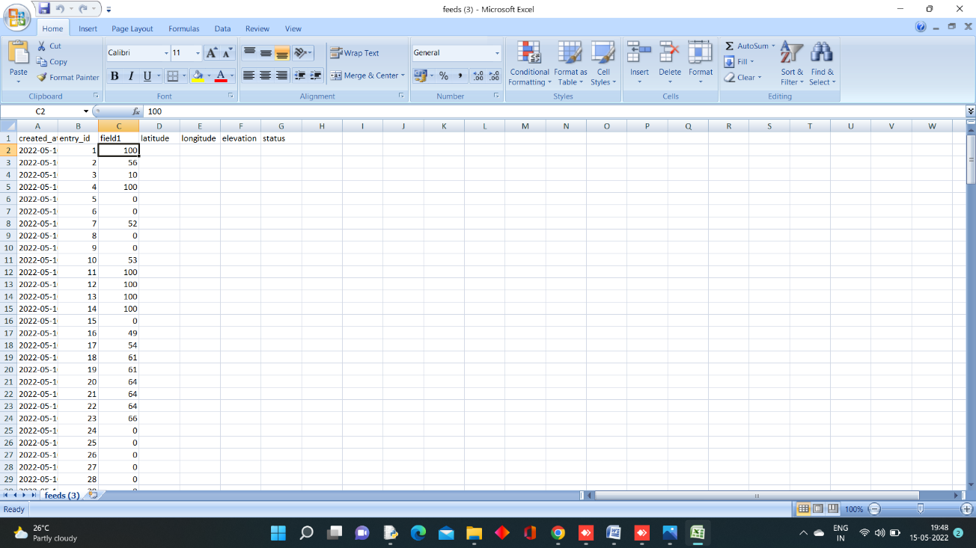

Fig A.14 Thingspeak application-Exported data

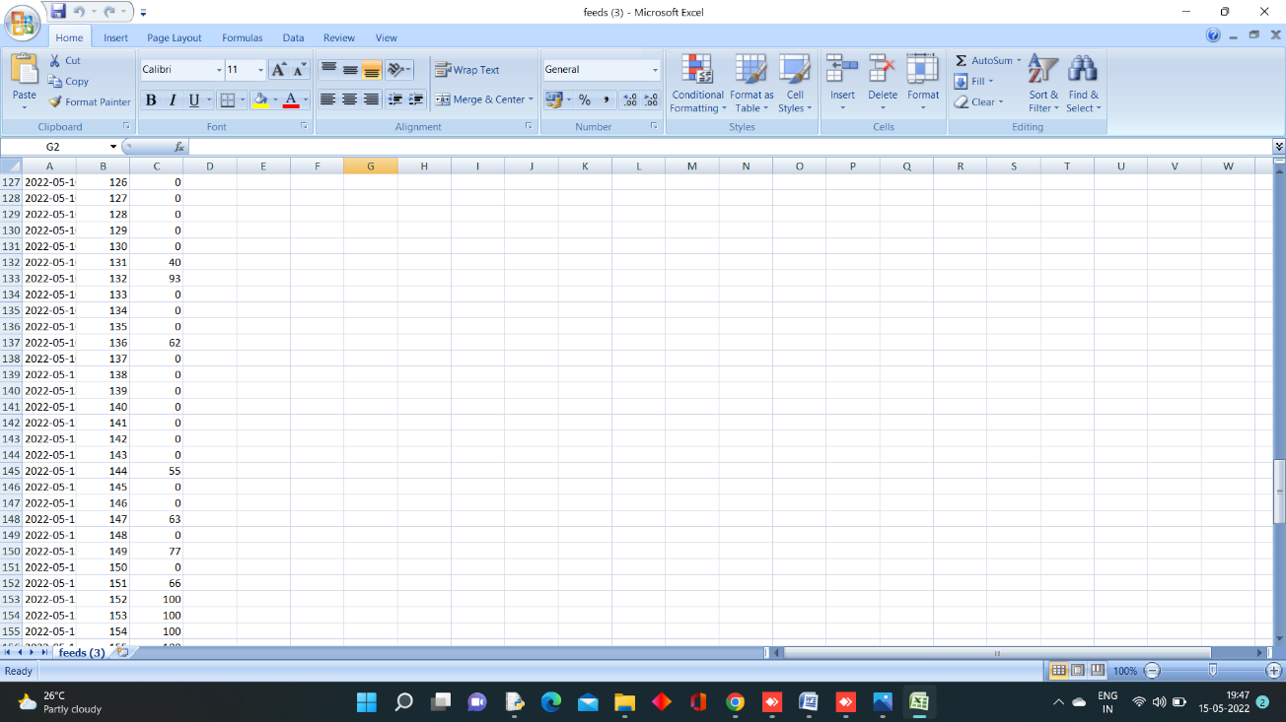

Fig A.15 Exported data continuation

**ThingView application from Parents or Therapist side:**

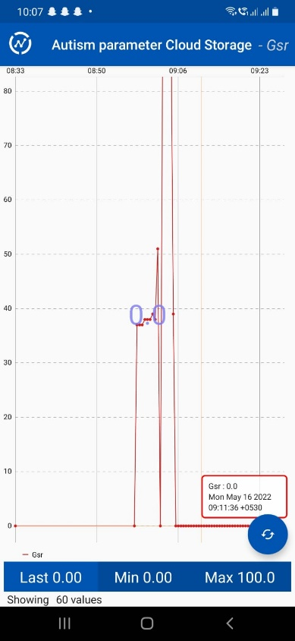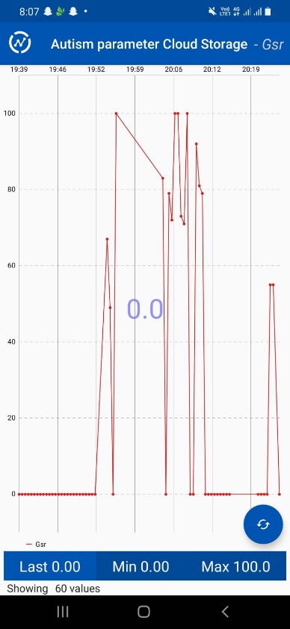

Fig A.16 ThingView Free Application from parents and therapist side

**REFERENCES**

1. Y. M. Al-Farsi, M. M. Al-Sharbati, O. A. Al-Farsi, M.S. Al-Shafaee, D. R. Brooks, and M. I. Waly, “BriefReport: Prevalence of Autistic Spectrum Disorders in the Sultanate of Oman,” *Journal of Autism and developmental Disorders,* vol. 41, no. 6, pp. 821–825, Jun. 2011.
2. V. Eapen, A. A. Mabrouk, T. Zoubeidi, and F. Yunis, “Prevalence of Pervasive Developmental Disorders in preschool Children in the UAE*,” Journal of Tropical Pediatrics*, vol. 53, no. 3, pp. 202–205, Jan. 2007.
3. M. AL-zaalah, A. AL-asmari, H. AL-malki, N. AL-shehri, N. AL-moalwi, and O. Mostafa,“Characteristics of Autism Spectrum Disorder among Saudi Children and its Impact on their Families,”*MEDICAL JOURNAL CAIRO UNIVERSITY*, vol. 83,no. 2, pp. 239–244, 2015.
4. F. M. Alnemary, F. M. Alnemary, and Y. A. Alamri,“Autism Research: Where Does the Arab WorldStand?,” *Review Journal of Autism and Developmental Disorders*, vol. 4, no. 2, pp. 157–164,Jun. 2017.
5. E. DiCicco-Bloom et al., “The Developmental Neurobiology of Autism Spectrum Disorder,” *Journal of Neuroscience,* vol. 26, no. 26, pp. 6897–6906, Jun. 2006.
6. D. P. Wall, J. Kosmicki, T. F. DeLuca, E. Harstad, and V. A. Fusaro, “Use of machine learning to shorten observation-based screening and diagnosis of autism,” Translational Psychiatry, vol. 2, no. 4, pp. e100–e100, Apr. 2012.
7. Brett Baisch, Sean Cai, Zongming Li, Victor Pinheiro, “Reaction Time of Children With and Without Autistic Spectrum Disorders”, 03-Jun-2017.
8. W. Liu, M. Li, and L. Yi, “Identifying children with autism spectrum disorder based on their face processing abnormality: A machine learning framework: Face Processing in Autism,” Autism Research, vol. 9, no. 8, pp. 888–898, Aug. 2016.
9. H. Zhao, A. R. Swanson, A. S. Weitlauf, Z. E. Warren, and N. Sarkar, “Hand-in-hand: A communication-enhancement collaborative virtual reality system for promoting social interaction in children with autism spectrum disorders,” IEEE Trans. Human-Machine Syst., vol. 48, no. 2, pp. 136–148, Apr. 2018.
10. Z. Zheng, G. Nie, A. Swanson, A. Weitlauf, Z. Warren, and N. Sarkar, “A randomized controlled trial of an intelligent robotic response to joint attention intervention system,” J. Autism Develop. Disorders, vol. 50, pp. 1–13, Feb. 2020.
11. Guangtao Nie and Akshith Ullal , Zhi Zheng , Amy R. Swanson , Nilanjan Sarkar, “An Immersive Computer-Mediated Caregiver-Child Interaction System for Young Children With Autism Spectrum Disorder” IEEE, 978-1-7281-4245-6, VOL 29, 2021.
12. Geraldine Dawsfon, Kimberly L. H. Carpenter, Kathleen Campbell, Qiang Qiu, Steven Espinosa, Samuel Marsan, Jeffrey P. Baker, Helen L. Egger, “Computer Vision Analysis for Quantification of Autism Risk Behaviors”, IEEE, Aug 2018
13. Alanoud Bin Dris, Abdulmalik Alsalman, Areej Al-Wabil, Mohammed Aldosari, “Intelligent gaze-based screening system for autism”, IEEE, 978-1-7281-0108, 2019
14. V. Y Tittagalla, R. R. P Wickramarachchi, G. W. C. N. Chandrarathne, N. M. D. M. B. Nanayakkara, P. Samarasinghe, P. Rathnayake and M.G.N.M. Pemadasa. “Screening Tool for Autistic Children”, IEEE, 978-5386-7512-0, 2019
15. Lian Zhang, Ashwaq Z. Amat, Huan Zhao, Amy Swanson, Amy Weitlauf, Zachary Warren, “Design of an Intelligent Agent to Measure Collaboration and Verbal-Communication Skills of Children with Autism Spectrum Disorder in Collaborative Puzzle Games”
16. Zeyad Abdulhameed Taha Ahmed , Dr. Mukti E. Jadhav, “A Review of Early Detection of Autism Based on Eye-Tracking and Sensing Technology”, IEEE, ISBN:978-1-7281-4685-0, 2020
17. Shirajul Islam, Tahmina Akter, Sarah Zakir, Shareea Sabreen, Muhammad Hossain, “Autism Spectrum Disorder Detection in Toddlers for Early Diagnosis Using Machine Learning”, IEEE, 978-1-6654-1974-1, 2020
18. Uzma Hasan, Md. Fourkanul Islam , Muhammad Nazrul Islam , Sifat Bin Zaman , Shaila Tajmim Anuva, Farhana Islam Emu, and Tarannum Zaki, “Towards Developing an IoT Based Gaming Application for Improving Cognitive Skills of Autistic Kids”, IEEE, 411-423, 2020.
19. Joao F. Santos, Nirit Brosh , Tiago H. Falk1 , Lonnie Zwaigenbaum, Susan E. Bryso , Wendy Roberts , Isabel M. Smith , Peter Szatmari and Jessica A. Brian, “Very Early Detection Of Autism Spectrum Disorder Based On Acoustic Analysis Of Pre-Verbal Vocalization Of 18-Month Old Toddlers”, IEEE, 978-1-4799-0356-6, 2013
20. P. Mundy, “Joint attention and social-emotional approach behavior in children with autism,” Develop. Psychopathol., vol. 7, no. 1, pp. 63–82, 1995
21. L. Billeci et al., “Disentangling the initiation from the response in joint attention: An eye-tracking study in toddlers with autism spectrum disorders,” Transl. Psychiatry, vol. 6, no. 5, p. e808, May 2016
22. Sarah Afiqh Mohd Zabidi, Hazlina Md Yusof, Sukreen Hana Herman, Shahrul Naim Sidek, “Simple Touch Sensor-based Game as Ambient Assistive Device for Mild Autism Spectrum Disorder Children**”** , IEEE, 978-1-7281-4245-6-6-21, 2021